IP 2: Artificial Intelligence
- Who were these people and how did/does each contribute to the development of AI? How did/does each think “intelligence” could be identified (50 words each).

Person | My response | ChatGPT’s response
Alan Matheson Turing  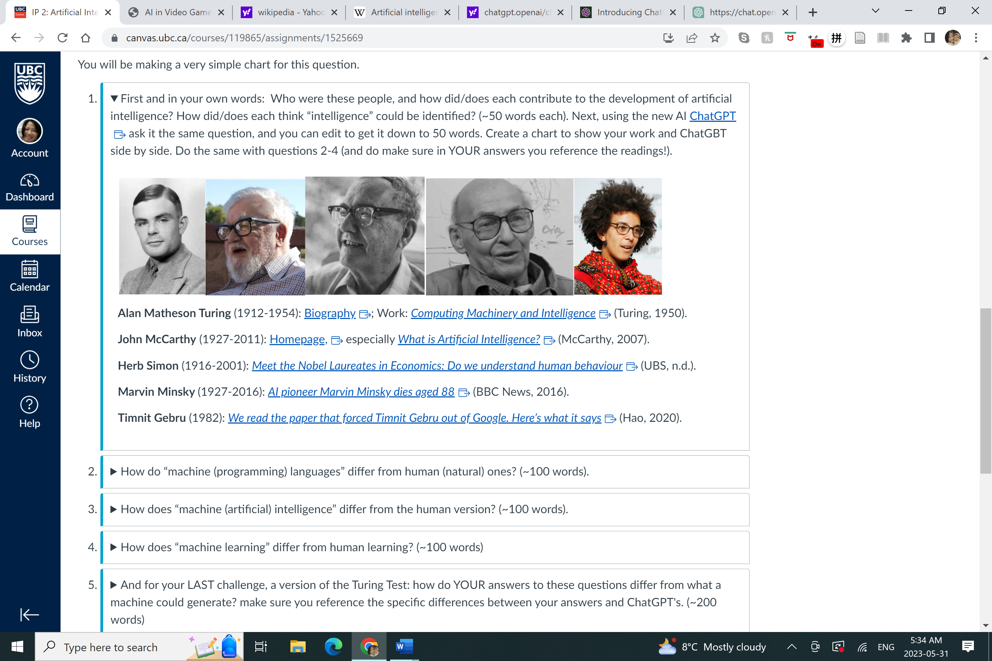 | Alan Turing was a gifted British mathematician who is best known for deciphering Nazi codes during WWII. His work is credited for laying the foundation for modern computer science and artificial intelligence. His Turing Test assesses artificial intelligence by testing whether it is indistinguishable from human intelligence (Biography, 2020). (47 words) | Alan Turing was a British mathematician and computer scientist who made notable contributions to AI. He devised the concept of the universal Turing machine, which laid the foundation for modern computing. Turing proposed that "intelligence" could be identified through a machine's ability to exhibit human-like behavior, such as language understanding, learning, and problem-solving. (53 words)
John McCarthy | John McCarthy was an American mathematician and computer scientist who coined the phrase “artificial intelligence”. AI is the science and engineering of making intelligent machines, expecially computers that would be able to solve problems and achieve goals in the real world as well as humans (McCarthy, 2007). (45 words) | John McCarthy was an American computer scientist known for his contributions to the development of artificial intelligence (AI). He coined the term "artificial intelligence" and played a key role in the development of the programming language Lisp. McCarthy believed intelligence could be identified by a machine's ability to exhibit human-like behavior and solve complex problems. (55 words)
Herb Simon | Herb Simon was a brilliant American political scientist who was influential in computer science, economics and cognitive psychology (“Herb A. Simon”, 2023). Credited as one of the founding father of AI, Herb wrote the first AI program in 1956 (Andresen, 2001). His area of interest revolved around finding out how people make decisions and their implications. (56 words) | Herb Simon, an American social scientist and computer scientist, made significant contributions to the development of artificial intelligence (AI). Collaborating with Allen Newell, they created the Logic Theorist, an early AI program. Simon identified intelligence as the machine's capability to solve problems and make logical decisions using heuristics and reasoning. (50 words)
Marvin Minsky | Marvin Minksy was an American mathematician, cognitive and computer scientist (“Marvin Minsky”, 2023). Together with John McCarthy, they co-founded MIT’s AI lab. He also built the first neural network simulator (Dennis, 2023). In his book Theory of Minds, he writes about how intelligence is a product of the interaction of non-intelligent parts. (52 words) | Marvin Minsky was an American cognitive scientist and co-founder of the field of AI. He made significant contributions to AI through his research on neural networks, perception, and robotics. Minsky believed "intelligence" could be identified by a system's ability to think, reason, and solve problems autonomously, while emulating human cognitive processes. (51 words)
Timnit Gebru | Timnit Gebru is an Ethiopian-born American computer scientist who specializes in AI ethics and data mining. She founded Black in AI for Black researchers in AI as well as Distributed Artificial Intelligence Research Institute (DAIR). She is concerned with creating AI that is unbiased, energy efficient, environmentally sustainable and equitable to all (“Timnit Gebru”, 2023). (52 words) | Timnit Gebru is a leading AI ethics researcher who has highlighted biases and social implications. She advocates assessing "intelligence" by a system's alignment with human values, managing uncertainty, and addressing societal challenges. Gebru's work emphasizes responsible and inclusive AI development, promoting ethical considerations for a fair and equitable future. (49 words)

References:
Andresen, S. L. (2001). Herbert A. Simon: Ai pioneer. IEEE Intelligent Systems, 16(4), 71–72.
https://doi.org/10.1109/5254.941361

Biography. (2020, July 22). Alan Turing. https://www.biography.com/scientists/alan-turing

Dennis, M. Aaron (2023, January 20). Marvin Minsky. Encyclopedia Britannica.
https://www.britannica.com/biography/Marvin-Lee-Minsky

Hao, K. (2020, December 7). We read the paper that forced Timnit Gebru out of Google. Here’s what it
says. https://www.technologyreview.com/2020/12/04/1013294/google-ai-ethics-research-paper-forced-out-timnit-gebru. MIT Technology Review.

Herbert A. Simon. (2023). Retrieved May 31, 2023, from https://en.wikipedia.org/wiki/Herbert_A._Simon.

Marvin Minsky. (2023). Retrieved May 31, 2023, from https://en.wikipedia.org/wiki/Marvin_Minsky.

McCarthy, J. (2007, November 12). What is Artificial Intelligence?
https://www-formal.stanford.edu/jmc/whatisai/whatisai.html

Timnit Gebru. (2023). Retrieved May 31, 2023, from https://en.wikipedia.org/wiki/Timnit_Gebru.

- How do “machine (programming) languages” differ from human (natural) ones? (~100 words).

My response | ChatGPT’s response
Human language includes morphology which is “the study of words, their formation, their relationship with other words in the same language, as well as the ways context can change a word’s pronunciation and meaning” (Harris, 2018). It is expressive and includes more complex parts of speech such as analogies, idioms, slang, irony and cultural phenomena. However, programming languages are predetermined so they are more precise and less original. It does not include the rich, complex structures of morphology seen in human languages (Harris, 2018). It adheres to strict rules of grammar and sentence formation thus lacks the flexibility of human language that allows it to evolve. (106 words) | Machine (programming) languages and human (natural) languages exhibit notable differences. Machine languages, designed for computer communication, adhere to strict syntax and grammar, offering precision and determinism. They lack ambiguity and allow no room for interpretation. In contrast, human languages serve diverse human communication purposes, accommodating flexibility, context, and subjective interpretation. Natural languages feature intricate structures, idiomatic expressions, and figurative language, reflecting cultural influences. They are adaptable, expressive, and capture the richness of human communication. While machine languages excel in precise instructions for computers, human languages thrive in the nuanced and multifaceted realm of human expression, fostering connection and understanding. (99 words)

References:

Harris, A. (2018, October 31). Human languages vs. Programming languages. Medium.
https://medium.com/@anaharris/human-languages-vs-programming-languages-c89410f13252

- How does “machine (artificial) intelligence” differ from the human version? (~100 words).
For example, read the full article On the Measure of Intelligence. or just the Abstract. (Chollet, 2019).

My response | ChatGPT’s response
Machine intelligence is defined as “skill-acquisition efficiency and highlighting the concepts of scope, generalization difficulty, priors, and experience” (Chollet, 2019). Knowledge is acquired through exposure to material and consistent practice (Simplilearn, 2023) whereas human intelligence is a cognitive process with the ability to think, reason, evaluate and adapt to changing situations. It can also be abstract, imperfect, inventive and creative. AI lacks creativity, intuition and emotional intelligence, is unable to adapt to new and unexpected situations and cannot provide moral or ethical considerations in decision-making that is found in human intelligence (shivani_21, 2023). Further, AI does not need rest and can process information much faster than humans. (106 words) | Machine (artificial) intelligence differs from the human version in several ways. Firstly, machine intelligence is based on algorithms and data processing, while human intelligence stems from biological processes and cognitive abilities. Machines excel in computational tasks and pattern recognition, but human intelligence exhibits creativity, intuition, and emotional understanding. Secondly, machine intelligence operates within predetermined boundaries and relies on programmed rules, whereas human intelligence is adaptable and can handle novel situations. Human intelligence also encompasses social and ethical considerations, whereas machine intelligence lacks inherent moral judgment. While machines can outperform humans in specific tasks, they still fall short in replicating the complexity and breadth of human intelligence. (106 words).

References:
Chollet, F. (2019, November 5). On the Measure of Intelligence. 1911.01547.pdf (arxiv.org)

shivani_21. (2023, May 3). Differences Between Artificial Intelligence and Human Intelligence. GeeksforGeeks.
https://www.geeksforgeeks.org/difference-between-artificial-intelligence-and-human-intelligence/

Simplilearn. (2023, June 5). Artificial Intelligence vs. Human Intelligence.
https://www.simplilearn.com/artificial-intelligence-vs-human-intelligence-article
- How does “machine learning” differ from human learning? (~100 words) For example, read Why algorithms can be racist and sexist. A computer can make a decision faster. That doesn’t make it fair. (Heilweil, 2020) and Artificial Intelligence Has a Problem with Gender and Racial Bias. Here’s How to Solve it. (Buolamwini, 2019).
My response | ChatGPT’s response
Machine learning exposes a computer to massive data sets where through patterns, it learns how to make judgments or predictions about the information it processes (Heilweil, 2020). However, based on old or training input data, algorithmic bias is inevitable especially against women and people of colour (Buolamwini, 2019). Human learning is achieved through the experience of “a model expressing a pattern in a set of observations” (Goel, 2020). It uses analogical reasoning and critical thinking that can be applied across different domains. Machine learning lacks this ability because they are programmed to solve only specific types of tasks (Alibabic, 2021). (99 words) | Machine learning differs from human learning in several ways. Machine learning relies on algorithms and data analysis, while human learning is a cognitive and experiential process. Machines learn from large datasets and identify patterns, while humans learn through observation, reasoning, and contextual understanding. Machine learning is task-specific and focused on optimizing performance, while human learning is holistic and transferable across different domains. Additionally, machines lack emotional and intuitive capabilities that are inherent in human learning. In summary, machine learning is a data-driven process, while human learning encompasses a broader range of cognitive abilities and experiences. (95 words)

References:

Alibabic, L. (2021, March 23). Machine Learning vs Human Learning: What’s the Difference? EDM Chicago.
https://www.edmchicago.com/machine-learning-vs-human-learning/

Buolamwini, J. (2019, February 17). Artificial Intelligence Has a Problem With Gender and Racial Bias. Here’s How
to Solve It. Time. https://time.com/5520558/artificial-intelligence-racial-gender-bias/

Goel, G. (2020, May 31). Human Learning vs Machine Learning: Getting down to the fundamentals of Learning…..
Medium. https://towardsdatascience.com/human-learning-vs-machine-learning-dfa8fe421560

Heilweil, R. (2020, February 18). Why algorithms can be racist and sexist: A computer can make a decision faster.
That doesn’t make it fair. https://www.vox.com/recode/2020/2/18/21121286/algorithms-bias-discrimination-facial-recognition-transparency

- And for your LAST challenge, a version of the Turing Test: how do YOUR answers to these questions differ from what a machine could generate? make sure you reference the specific differences between your answers and ChatGPT's. (~200 words)
For this last question, think about whether your responses only reported information derived from online searches? In your responses to these questions, what transformative kinds of thinking and/or reasoning processes have you engaged in order to formulate your answers, that exceed or differ from what artificial intelligence can do? Do you think there are ANY distinguishing features that would identify your responses as having been formulated by a human, and not a machine, intelligence? What and why?

My response | ChatGPT’s response
My answers were formed through a synthesis of general knowledge acquired over the years through observed patterns from life experiences, and also from internet research. However, the most obvious trademark of my human responses is characterised by imperfection in structure, simplicity of diction and sometimes grammar errors (See what I did there?). Distinguishing features of human intelligence found in my responses are evident in that my sentences read a bit scattered and not as coherently crafted together as found in calculated, machine-generated responses. There may be a more personal, stylized and nuanced approach to my answers that expresses creativity but also insecurity. I find myself wafting between attempting to write formally and writing colloquially (along with implied humor). ChatGPT is more articulate, cohesive, perfectly structured and direct. My answers feel more like a stream of consciousness because they are a result of messy, cognitive processes. Given identical factors of font, font size and column width, I employed simpler use of diction that appears quantifiably much less than ChatGPT’s responses despite word counts being exactly the same. This is interesting because while I seek simplicity, the machine-generated responses have a level of complexity and impersonal formality not found in my responses. (200 words). | Human answers and machine-generated text demonstrate fundamental disparities across various dimensions. Human answers are the product of intricate cognitive processes, integrating personal knowledge, experiences, emotions, and contextual understanding. They possess the remarkable capacity to convey nuanced information, exhibit creativity, and encompass subjective perspectives. Additionally, human answers are shaped by cultural, social, and ethical considerations, making them incredibly diverse and multifaceted. In contrast, machine-generated text relies on algorithms and AI models that have been trained on vast datasets. While machines excel in processing massive volumes of information rapidly and accurately, their responses often lack the depth, subtlety, and human touch that characterize human answers. Machine-generated text tends to adhere to statistical patterns and predefined structures, limiting its creativity, intuition, and originality compared to humans. Although human answers can be influenced by biases and errors, they also possess the potential to incorporate diverse viewpoints and foster critical thinking. Moreover, human answers facilitate interpersonal connections and emotional resonance, elements that machine-generated text finds challenging to emulate. Ultimately, human answers encapsulate the remarkable complexity of human cognition by integrating emotions, context, and subjective understanding, whereas machine-generated text, while efficient and reliable, falls short in capturing the same depth, human qualities, and genuine human connection. (200 words)

